Please follow the steps to install talisman on your tsys laptop(to deep dive what is Talisman, here is the github linke - <https://github.com/thoughtworks/talisman>):-

1. Run following command to install talisman as a pre commit hook (to scan new changes per commit)

curl --silent https://raw.githubusercontent.com/thoughtworks/talisman/master/global_install_scripts/install.bash > /tmp/install_talisman.bash && /bin/bash /tmp/install_talisman.bash

1. It will ask for **Where you want to set up the TALISMAN_HOME variable**, you can choose any of the options prompted by it or can set manually also in your .zshrc.

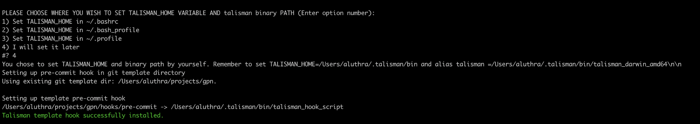

1. It will use the existing git template (specified in your .gitconfig).
2. Next it will ask for ***Please enter root directory to search for git repos*** , enter the directory path for your project workspace where you have existing gpn repos like ***/Users/{yourusername}/gpn***

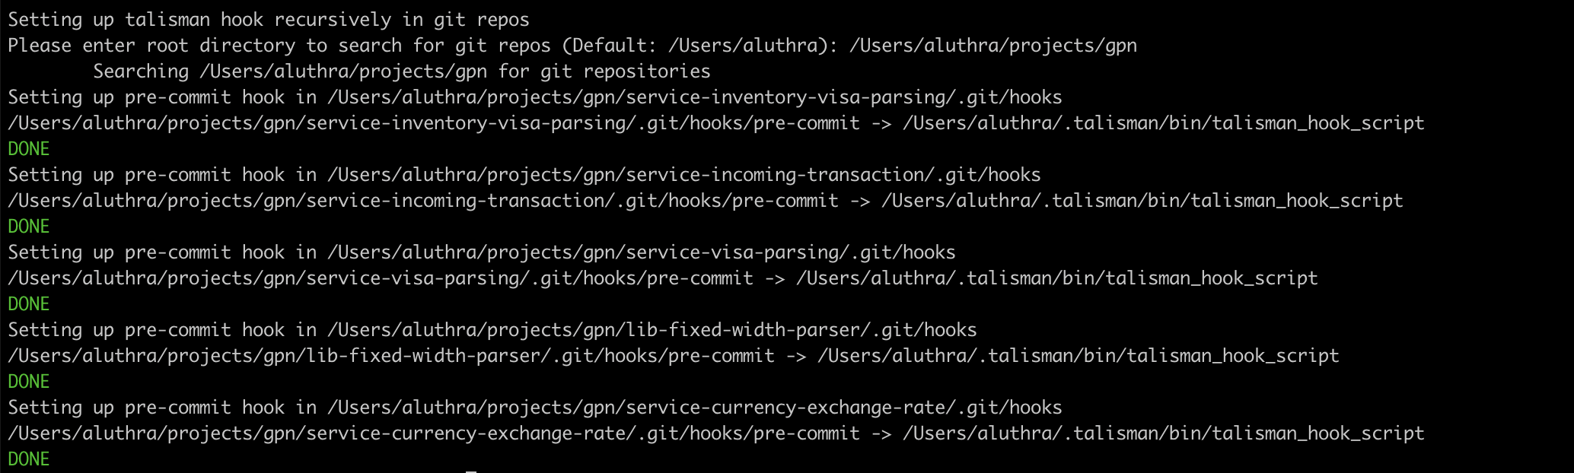

1. It will add the hooks and set up the talisman for all repositories under the path chosen in point 4.
2. Next, if you clone any new repository anywhere, it should add a talisman pre commit git hook automatically at the time of cloning(referring to the global git template), nothing extra needs to be done.
3. You can test whether the hook is working properly by adding a potential password in proxyPassword in gradle.properties (something like - FJpCkJ43CgxQkijZkLT) and try to commit, it should not allow the commit and show a talisman prompt like: